# Dup and Max’s Grocery! Report

Admin user is arnold. Regular users is everyone else.

## Mission Statement:

The audience of Dup and Max’s Grocery! are medical doctors, students, and teachers. Our goal is to make make access to human organs easier and faster for doctors, whose patients are often in a emergency and need such fast and efficient supply of organs as our website provides. Hence, our website keeps its features to the bare minimum for faster access and quick supply. Our website hopes to see more people survive from organ transplants.

## Executive Summary:

The world will be in distress with the lack of organ donors and suppliers thereof. A wise government predicts a famine and stores wheat and grain before it actually comes. Dup and Max’s Grocery! is a forerunner in the race to helping people with organ transplants, when the famine of organs hits the world. The high-speed and super efficient way of purchasing our products will save many lives. In order to make things high-speed and super efficient, we have made our website as simple as possible.

Our website believes in transparency of the government. Following the maxim of beating everyone in the race before it even starts, we have made our website transparent in some data. We have made it so that one can see all the past orders of our website, the data of which may be valuable to our customers who suspect the validity and legitimacy of our company, as is often the case when one tries to buy organs.

Our website embraces the color of pink and light purple to alleviate the dark shadow that our market casts on us. Supplying organs can leave an image of something dark and fishy in the minds of customers, so we have embraced the loving color of pink and light purple. Moreover, our website embraces the sharing of opinions and thoughts in the review section, which will hopefully make our website be a better solace for the great lack of organ supply that will come in the future.

# System Features:

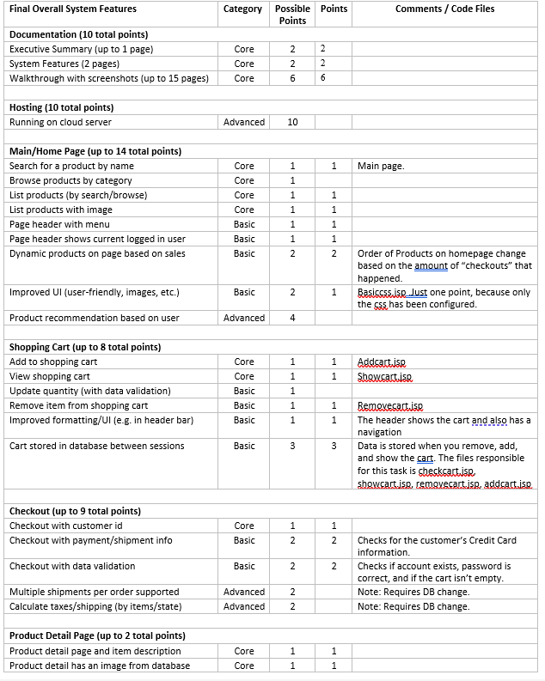

# Walkthrough with screenshots:

|  |  |
| --- | --- |
|  | This is the main page.  You can browse for the products at the bottom of the page.  The signed in person is shown. Header also exists. |
|  | If you click “Begin Shopping,”  You can browse for the products there as well. |
|  | If you click on the product,  You can see the details of the product.  You can see the warehouse inventory numbers, price, description, and review. |

|  |  |
| --- | --- |
|  | You can add stuff to the cart.  You can remove stuff.  Data is stored on the database and on session.  If you logout, you can lose your cart.  If you login, you get a new cart based on what’s on the DB. |
|  | If you click checkout,  You have to enter your userid (username) and password to continue. If you did not put anything in cart, then you will get an error. |
|  | You have to enter your credit card information in order to check out. If month and year is invalid, (like the year 2021, or month 21), it will give an error. |

|  |  |
| --- | --- |
|  | Once you have completed the checkout, this is the page you get to. |
|  | After that, if you go to the homepage, you can see why the main page is “dynamic.” At the bottom of the screenshot, it says,  “Check out our hottest products!”  This list of products change according to how many and what products were checked out. |
|  | You can view all the orders of the website. |

|  |  |
| --- | --- |
|  | You can see the customer info after you are logged in.  You can edit your customer info and also make a review here. |
|  | You can edit your account details here. You have to enter valid values for each of the text boxes. |
|  | You can make a review here. You cannot review anything if you have not purchased the product and you can only review a product once. |
|  | All orders for the user can be displayed as well. |

|  |  |
| --- | --- |
|  | As you can see below, If you review for something twice or have not ordered it, you get redirected to the Customer Info page and you are given this message below. |
|  | This is the admin page. You can reinitialize, add a product, remove a product, and list all customers here. The “MESSAGE” header is there to show any errors that happen. |
|  | You can add a product here. Images cannot be uploaded. If incorrect information is given, the “MESSAGES” tab in the admin page will give you an error. |

|  |  |
| --- | --- |
|  | As you can see below, If you review for something twice or have not ordered it, you get redirected to the Customer Info page and you are given this message below. |
|  | You can remove a product. |
|  | You can list all customers. |

|  |  |
| --- | --- |
|  | You can create an account. It checks to see if a user with the same name is already in the database. Thus, it does data validation. |
|  |  |
|  |  |